
Durham Convention Center Authority Meeting
Thursday, October 31, 2019
Durham Convention Center
301 West Morgan Street

DCC Authority Members Present: Pashara Black, Richard Ford, Lew Myers, Craig Spitzer, and Darah Whyte. Spectra Venue Management (SVM) Present: Rebecca Bolton and Andrea Gliatta
City and County Representatives Present: Drew Cummings, Sharon DeShazo, April French, Carlos McCall, Trish Creta, David Boyd, and Jina Propst

- A quorum was established for meeting minute’s approval. Lew Meyers made a motion to approve August 29, 2019 meeting minutes; seconded by Darah Whyte, motion carried; minutes approved.

- Rebecca Bolton and Craig Spitzer, DCCA chair plan to schedule time for discussion on DCC current projects and operations with the Pashara Black, the new DCCA member.

- REBRANDING:
The rebranding project is on hold. Stay tuned.

- DURHAM City/County Administration Update:
Capital Projects: FY2019: Budget:
Fireproofing
PFC $66,000
Loading Dock - Shared $21,000
Additional funds needed for loading dock ($8,000) estimate
- Contracted work completed in mid-October.
- Six additional areas of delaminated spray fireproofing were identified. Funding is requested for FY2021 once a final estimate is received. The initial rough order of magnitude is approximately $100,000. The contractor is currently preparing a more detailed estimate.
Kitchen Equipment Improvements (equipment and installation) $53,000
Phase I
  - The dish pit equipment is being ordered.
  - Kitchen work is being scheduled for December 30, 2019, and/or the first week of January 2020 since no DCC events are scheduled during this time.
  - The work is estimated to complete at $37,548, potentially having an excess of $15,000. General Services anticipates being over budget by a similar amount.
  - General Services is requesting that the DCCA approve reallocation of funding for Phase II once all quotes are received; these actions need to occur.

Capital Project FY2020 Budget:
Exterior Signage (Carryover to FY2020) $55,000
Additional funding needed $40,000
  - Images presented to the DCCA at the August 29, 2019 meeting.
  - The project was submitted to Planning for a Certificate of Appropriateness which will then forward to the Historic Preservation Commission at the December 3 meeting. There were no comments from Planning and the design was accepted.
  - Equity & Inclusion (E&I) accepted the signage project into the Small Local Business Enterprise Program (SLBE).
  - Bidding to SLBE general contractors expected in December/January and construction in late Winter/early Spring.
Kitchen Project Phase II
    - Kitchen Equipment $50,000
    - Kitchen Combi-Oven $24,000
    - Walk-in Freezer $28,000
    - Hot Boxes $4,000
    - Small-wares $30,000
      - Working with the same contractor and equipment installer from Phase I, and are preparing quotes for Phase II scope, and meetings are ongoing.
        - Rebecca and Shamona will arrange a site visit to investigate Combi-Oven preferences.
      - Work and equipment installation is being coordinated with Phase I for December 2019/January 2020.
      - Hot boxes and small-wares will be purchased in November/December 2019
        - Rebecca has quotes for these items and other small-wares. Quotes are under evaluation. Anticipate purchases by the end of the calendar year.
Interiors Projects
    - Looking to select an Interior Designer – mid-January $30,000
      - Investigating multiple options
- Bathroom Renovation $50,000
Timeliness of the bathroom project is on track
- Prefunction Furniture $29,274
  - General Services recommends approval of RND for interior design project, due to consistency and efficiency from current involvement with the Signage project, as well as knowledge of facility from other past interior projects. Selection of designer to occur in mid-January.
Airwall Damage $44,000
DCCA approved use of additional $26,000 from HVAC project for Airwall damage at August 29 meeting. The HVAC equipment project has been deferred three to five years out.
- Finalizing review of quotes received to initiate project in early spring. Materials are a long lead item (approximately 15 weeks order time).
Wireless Upgrade $40,000
- Quote received and contract expected in mid-November
- Anticipate project completion by February 2020.
Security System $40,000
  - Quotes and contracts are expected by mid-November. Working with additional Project Manager.
  - Anticipating work between December 30 and January 10.
ADDITIONAL PROJECTS BUDGET
(Funds Needed)
Database Software Upgrade $7,000
Computer Replacement $9,000
- Currently reviewing DCC computer inventory and required upgrade from Windows 7, which is obsolete.
- Quotes received from NC State contract vendor.
- Current budget count for eleven computers and installation, but count is an estimate and needs finalization by DCC. These items are not currently allocated in the Capital FY2020 budget; therefore require approval from the DCCA and staff. Based on the urgent need and critical nature of this request, the DCCA can approve and staff will move forward with next steps. Project Manager will use the City’s computer vendor – Dell.
  - On behalf of the DCCA, Richard Ford made a motion to approve reallocation of funding up to approximately $20,000 to the DCC for the replacement of outdated computer equipment and software. Lew Myers seconded; motion carried and approved by all.
Mural and Lighting for Mural
- Cornelio Campos’ mural is complete.
- Cecelia Lueza’s mural is complete.
- Cost of murals is shared with North Carolina Museum of Art at $15,000 each.
- Maintenance procedures will be discussed at a later time.
- Google Fiber paid for LED back-lighting for murals which is over $5,000.

- SPECTRA VENUE MANAGEMENT (SVM) UPDATE:
Events for the month of September 2019
SVM held 36 events with 10,105 guests.
Notable events: DCC Revenue Guests
      - Carolina Parking Association (4 day event) $49,212 600
      - Duke Office of Development (One day meeting) $30,000 300
      - Duke Medical Cell Therapy (One day meeting) $23,720 380
      - NIEHS (4 day meeting) $36,765 516
      - ISMTE (4 day convention) $64,831 690
      - NC Clean Energy (3 day convention) $63,715 575
      - SETAC ( Seven day convention) $76,063 2032
      - Empire Distributors (One day tradeshow) $20,524 200

ADDITIONAL NOTES:
- Hired Shamona Taylor – Executive Chef from Mercedes Benz Stadium, Atlanta GA
- Gianni Fitts – Events Manager from Fayetteville NC
- Operations Manager Position will increase staff to 14 positions. This position will assist our Facilities Operations Manager in managing day-to-day staff.
- DDI Consultant – Tourism Masterplan
  - Input of the Steering committee will what needs should be prioritized and reviewed.
    - What is the growth potential?
- DCC Plaza – Thinned out some of the trees for improved visibility, painted light poles and changed photo cells on lights.
  - Jina Propst, interim General Services Director inquired why lights were operating during the mid-day. Once the inquiry was made, lights were turned off during day light hours.
- Citywide Events – Long Term Bookings – Hotel Rooms Blocks and Venue Contracts

FINANCIAL OVERVIEW FOR SEPTEMBER 2019
Actual Budget Variance
Gross Revenues $265,533 $230,057 $34,951
Less Event Expenses ($106,103) ($89,607) ($16,496)
Less Indirect Expense ($139,325) ($152,979) $13,654 ___
Net Income (Loss) $20,105 ($12,113) $32,210

FINANCIAL OVERVIEW Year-To-Date FY2020
Actual Budget Variance
Gross Revenues $715,844 $534,233 $181,611
Less Event Expenses ($289,960) ($206,037) ($83,923)
Less Indirect Expense ($432,010) ($491,894) $59,884 ___
Net Income (Loss) ($6,126) ($163,698) $157,572

2020 Annual Budget Revenue Projection Status
Total Projection | Budgeted Total Gross Income | % of the Gross Year-end Budget
$2,436,923 | $2,708,132 | 90%

Sales Pace for FY2020 as of October 29, 2019
Definite/Actual Total | $ 2,104,462
Firm Total | $ 116,737
Proposal Total | $ 215,724
Total Projection | $ 2,436,923

Rolling Forecast
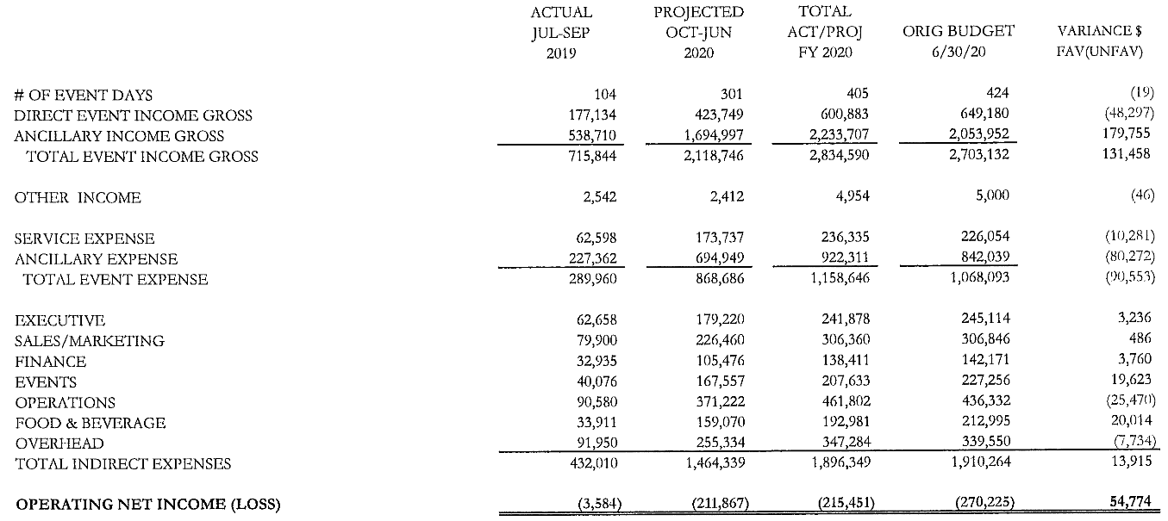

CUSTOMER SURVEY SCORES: 4.72 out of 5
WEBSITE ACTIVITY: August 16th – September 16th
2018 2019
  - Sessions (Visitors): 1,335 1,730
      - New Sessions: 86.9% 88.3%
      - Page Views 3,511 4,665
  - Page/Session: 2.63 2.70
  - Average Session duration: 1.28 minutes 1.16 minutes
  - Organic Search 729 969
  - Direct Search 276 475
  - Referral Search 94 54

- DCCA

- SUBCOMMITTEES
- FINANCE COMMITTEE: Lew Myers, Richard Ford, and Craig Spitzer
The DCCA received and reviewed the DCC FY2019 (Audit) 12 Agreed-Upon Procedures. David Boyd, City of Durham Finance Director, discussed the FY2019 audit with the committee regarding Spectra’s operations and noted it was well received with minimal changes based on DCC financials provided. The results of the procedures were distributed at the meeting. The audit procedures were accepted.
City and County staff, the DCCA Finance Committee, and members of Spectra Venue Management discussed September 2019 financial results. There was discussion of DCC Capital Projects and notation that Capital funds flow through Finance (David Boyd). Changes can be made upon discussion, agreement and protocol of the process.
Operating revenues for the month exceed budget by $35,060. Expenses remain flat with a variance of ($2,842). Spectrum is being more conscience of spending and expenses are ahead of budget at $54,774. To-date there is $130,334 in outstanding receivables. Collection efforts are in place. The facility is experiencing fewer events, but revenues are increasing. A replacement Executive Chef rolled out a higher food cost with replacement of food inventory. Prior to the new chef, there was a gap in the kitchen inventory.

- MARKETING & SALES COMMITTEE: Bill Kalkhof, Darah Whyte, Alice Sharpe, and Craig Spitzer
Spectra Venue and members of the Marketing and Sales committee continue to collaborate on Spectra Venue’s DCC marketing plan.

