Configure PDF Convert for Rackspace (X64)
- Open the DCOM:
  - X64 OS: Start -> Run -> mmc comexp.msc /32
(X86 OS: c:\windows\system32\dcomcnfg.exe)

- Select Component Services -> Computers -> My Computer, right click to open properties dialog.
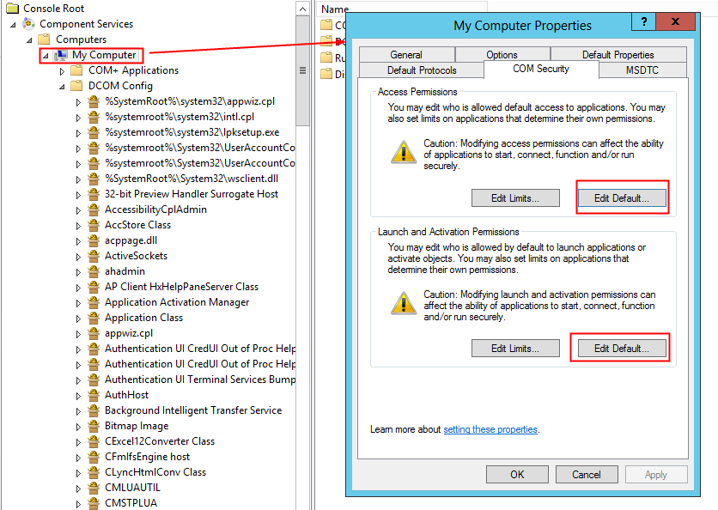

- Select COM Security tab, Edit default permissions, and Grant below permissions to “VDC1\CMS6User”
  - Access Permissions: “Local Access”
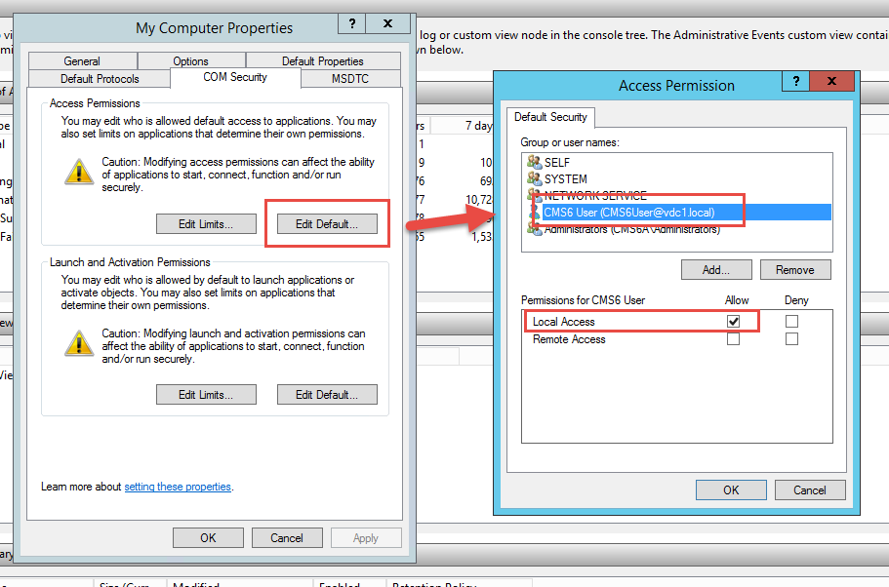

  - Launch and Activation Permissions: “Local Launch”, “Local Activation”
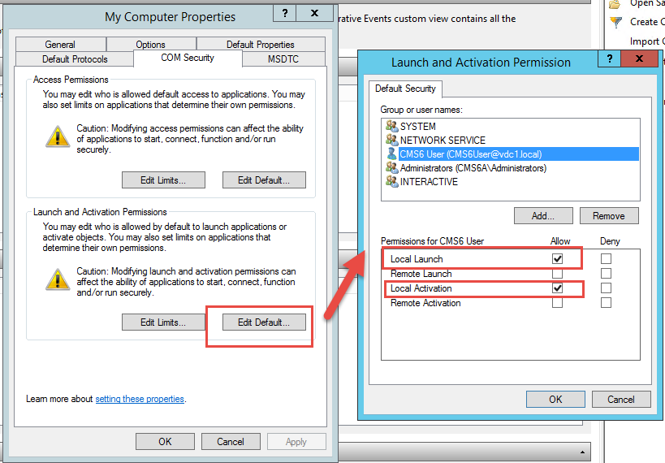

- Select My Computer -> DCOM Config -> Microsoft Word 97 – 2003 Document
  - General Tab: Set Authentication Level to “None”
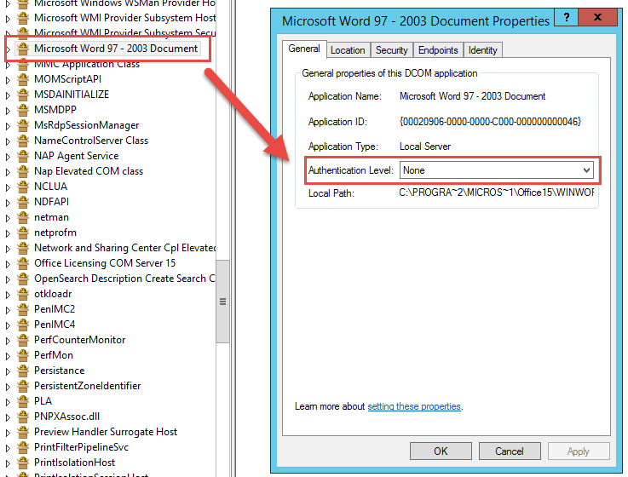
  - Location Tab: Check “Run application on this computer”
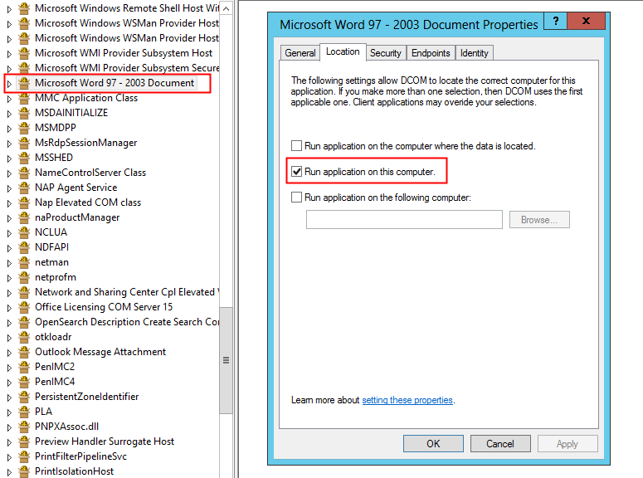

  - Security Tab: Make sure the “VDC1\CMS6USER” has related permissions
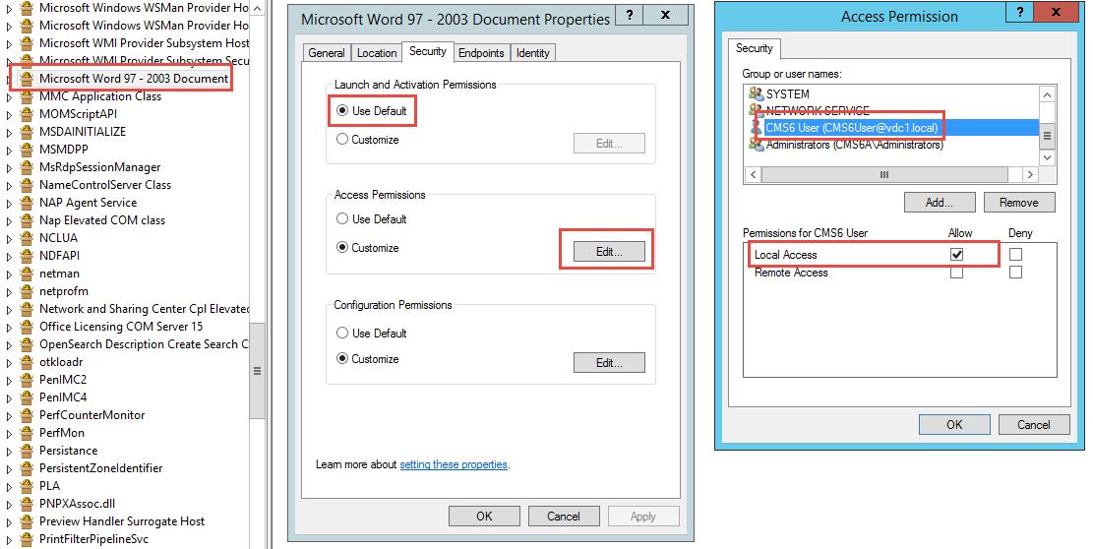

  - Identity Tab: Select “The launching user.”

USE THE INTERACTIVE USER HERE INPLACE OF LAUNCHING USER – Rahul’s comments
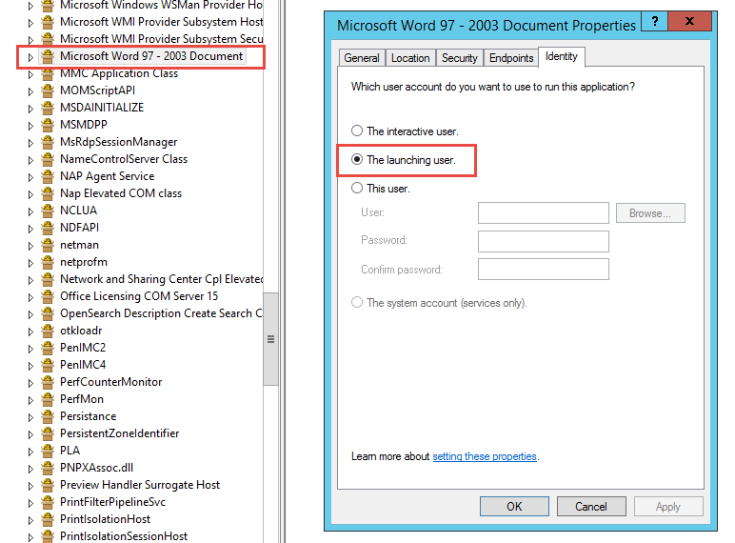

- Grant “VDC1\CMS6USER” permissions on following folders:
C:\Windows\Temp – Modify
C:\Windows\syswow64\config - Read
C:\Windows\syswow64\config\systemprofile – Read
C:\Windows\syswow64\config\systemprofile\AppData – Modify
C:\Windows\syswow64\config\systemprofile\Desktop – Modify (Create it if it does not exist)

Troubleshooting

1. If you encounter the error below from the CMS

2018/01/17 16:39:01:472 [ERROR] Vision.Cms.Mvc.Common.PDF.WordHtmlToPdfConverter - Convert the file [C:\WebSites\Bozeman - City of (MT)\Project\FileCenter\Temp\PdfConvert\P5R66R7S.pdf.html] to PDF failed: Retrieving the COM class factory for component with CLSID {000209FF-0000-0000-C000-000000000046} failed due to the following error: 800703fa Illegal operation attempted on a registry key that has been marked for deletion. (Exception from HRESULT: 0x800703FA).
Message:Retrieving the COM class factory for component with CLSID {000209FF-0000-0000-C000-000000000046} failed due to the following error: 800703fa Illegal operation attempted on a registry key that has been marked for deletion. (Exception from HRESULT: 0x800703FA).
Stack Trace: at Vision.Cms.Mvc.Common.PDF.WordHtmlToPdfConverter.Convert(String filePath, String pdfPath)

The application pool user was used to login to the server before, to fix this problem.

Cause

This error sometimes occurs if a logoff event is generated and the resolution below is not configured. This may occur when an app pool's identity is used to remote into the machine, or if it is shared by another app pool.

Resolution

This appears to be a known issue affecting Windows Server 2008 and WIndows Server 2008R2. From the MSDN forums, the solution is to make a change to your group policy.

You should change the following setting from "not configured" to "enabled":

Computer Configuration->Administrative Templates->System-> UserProfiles
Do not forcefully unload the user registry at user logoff.

If this does not work, or if you are unable to make this change, you can also try setting the "Load User Profile" setting on your prod app pool to true.

Refresh the app pool after this change.

